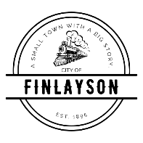
CITY COUNCIL
PLANNING AND ZONING WORKSHOP AGENDA
MAY 27, 2026 AT 6:00 PM
FINLAYSON CITY HALL

THIS IS A WORKSHOP AND NO DECISIONS WILL BE MADE. THIS WILL BE DISCUSSION BY THE CITY COUNCIL AND THE PUBLIC WILL HAVE THE ABILITY TO HEAR THESE DISCUSSIOS. NO OPEN FORUM FOR PUBLIC COMMENT.

- CALL TO ORDER - Pledge of Allegiance (1 minute)

- ROLL CALL (1 minute)

- OVERVIEW OF MOVING TO PINE COUNTY (10 minutes)
  - Why do we feel we need to move to Pine County
    - Negative Feels about current P & Z structure
    - No enforcement structure
    - Staffing Needs
    - Cost to the City
    - Liability for the City
  - Pros and Cons of moving to Pine County

- WHAT DO WE WANT PLANNING AND ZONING TO LOOK LIKE IN FINLAYSON (30 minutes)
  - Roles and Responsibilities
    - Planning and Zoning Administrator
    - Administrative Support
    - Commission Roles and Focus
  - Rural Area Structure/Focus
    - Review and revision of ordinances
    - Focus as community partnership
    - Cohesive partnership between all parties
    - Clear expectations defined
- ADJOURNMENT

