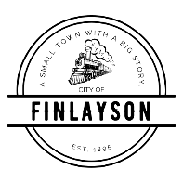
CITY COUNCIL
PUBLIC HEARING (BOLLIG)MEETING AGENDA
MARCH 9, 2026 AT 6:00 PM
FINLAYSON CITY HALL

- CALL TO ORDER - Pledge of Allegiance

- ROLL CALL

- BOLLIG Findings
- BOLLIG – Assistance with Grant Requests
- ADJOURNMENT

